**SAD**

## Abstract

The timely evolution of appropriate IT systems is vital to the wellbeing, efficiency and profitability of modern organizations.

Using interviews with the users, the report examines the use of the current system  in the directorate.

The findings include

1. xxxxxxxxxxxxxxxxxxxxxxxxxxxxxxxxxxxxxxxxxxxxxxxxxxxxxxxxxxxxxxxxxxxxx
2. xxxxxxxxxxxxxxxxxxxxxxxxxxxxxxxxxxxxxxxxxxxxxxxxxxxxxxxxxxxxxxxxxxxxx
3. Xxx
4. Xxx
5. Xxx
6. Xxx

The report concludes that while the system has operated well for a number of years, gaps  are beginning to emerge which are impacting on the current operations.

It proposes that in order for the directorate  to continue to use the system efficiently, it needs to

1. Xxxxxxxxxxxxxxxxxxxxxxxxxxxxxxxxxxxxxxxxxxxxxxxxxxxxxxxxxxxxxxxxxxxxx
2. Xxxxxxxxxxxxxxxxxxxxxxxxxxxxxxxxxxxxxxxxxxxxxxxxxxxxxxxxxxxxxxxxxxxxx
3. Xxxxxxxxxxxxxxxxxxxxxxxxxxxxxxxxxxxxxxxxxxxxxxxxxxxxxxxxxxxxxxxxxxxxx
4. Xxx
5. Xxx
6. Xxx

Based on these findings and analysis, the report recommends  that the current  system be improved.

## Table of Contents

Contents

i. Abstract ii

ii. Table of Contents iii

iii. List of Tables and Figures iii

Chapter 2 1

2.1 Introduction 1

6.1 Background 1

6.2 The Objectives of the Electronic File Tracking System were:- 1

6.3 Limitations and advantages 1

6.4 Overview of proposed (new) system 2

Requirements 2

Technical requirements 3

6.5 Use Cases 4

6.6 Work plan/schedule 5

6.7 Database Design 6

Data Dictionary 6

Database Modeling 16

User Interface 17

3.6.2 Forms Design 17

## List of Tables and Figures

Table 1: Work plan schedule Table 3

Table 2: Summary of activities to be undertaken 4

Table 3: Table Showing tables attributes, entities and relationships of the data 5

Figure 4: Data Model Diagram 10

Figure 5: Log in form 11

Figure 6: Main page 11

Table 4: Hardware Stack Summary Table 13

Table 5: Software Stack Summary Table 13

# Chapter 2

## Introduction

This proposes the adoption of a better PMMU Evaluation Information system than that used at present in order to enhance workplace productivity, efficiency and effectiveness.

The current system has been in use since (date) and is used for ( ...). Over the past several years  the need for a new system has become apparent due to

1. Need to incorporate  more functionality in the current system
2. Need to generate more useful reports
3. Need to automate repetitive tasks
4. Link the current information system with CTS to mine data

## Background

## The Objectives of the Electronic File Tracking System were:-

1. Electronic Physical tracking of each physical file
2. Monitoring usage of Files
3. Maintenance of records transactions

## Limitations and advantages

By observing the workplace and by drawing conclusions from the survey, the limitations and advantages of the current system can be inferred. These are summarised in Table 1 below.

Table 1: (Company information system) Limitations and Advantages

## Overview of proposed (new) system

### Requirements

The proposed solution will address the following concerns;

1. An open solution that is easily manageable and extensible.
2. REST API
3. Interoperability with future systems to be implemented by ICT Directorate
4. Web readiness
5. High security for data
6. Speed optimization and Lightweight resource utilization
7. Low Cost/ No cost licensing fee on the software and solution

# Technical requirements

Table 4: Hardware Stack Summary Table

|  |  |  |
| --- | --- | --- |
| Hardware | Component | Description |
| Server Side | * Judiciary Cloud |  |
| Client Side | * Computers |  |
| * Printers |  |
| * Network |  |

Table 5: Software Stack Summary Table

The project will utilize high quality, industry proven popular open source and free software, for web application and database as detailed below:

|  |  |  |
| --- | --- | --- |
| Software |  |  |
|  | **Component** | **Description** |
| Server Side | **Application Server**  **Backed end**   * Laravel 8 or higher | * Open source popular PHP Framework |
| **Frontend**   * Bootstrap 5 | * Open source technology to build responsive web interface |
| * VueJS and Livewire |
| **Database**   * MySQL | * Open source DBMS |
| **Web Server**   * Apache web server | * Open source Web Server * To serve static and dynamic pages |
| * Linux (CentOS) | * Open source operating System |

## Use Cases

Types o

## Admin

## User

## Work plan/schedule

Table 1: Work plan schedule Table

|  |  |  |  |
| --- | --- | --- | --- |
| Stage | Duration | Tasks | Deliverables |
| System Analysis | 1 Week | Analyze the current system in place, identify shortcomings and recommended a better solution. | Report |
| System Design | 4 Weeks | Database design  User interface design  Reports Design | Software code; |
| Data Migration |  | Migration from old database to new database | Migration scripts |
| Testing | 1 week | Test functionality and  compatibility of the  system;  Meet with clients; | Demonstration |
| Project finalization | 1 week | Deliver final presentation; | Oral presentation |
| User Training | 1 week | Train users |  |

Table 2: Summary of activities to be undertaken

|  |  |  |  |  |  |  |  |  |
| --- | --- | --- | --- | --- | --- | --- | --- | --- |
| Task | Wk1 | Wk2 | Wk3 | Wk4 | Wk5 | Wk6 | Wk7 | Wk8 |
| System Analysis |  |  |  |  |  |  |  |  |
| System Design |  |  |  |  |  |  |  |  |
| Testing |  |  |  |  |  |  |  |  |
| Project finalization |  |  |  |  |  |  |  |  |
| User Training |  |  |  |  |  |  |  |  |

## Database Design

Table 3: Table Showing tables attributes, entities and relationships of the data

### Data Dictionary

#### Users Table

|  |  |  |  |  |  |  |  |  |
| --- | --- | --- | --- | --- | --- | --- | --- | --- |
| Attribute Name | Contents | Type | Format | Range | Required | PK Or FK | FK Referenced Table |  |
|  | id | Auto number |  |  |  | YES | PK |  |
|  | email | Email of the user | String |  |  | YES |  |  |
|  | encrypted_password | Hashed password of the user | String |  |  | YES |  |  |
|  | reset_password_token | Key to reset password | integer |  |  | NO |  |  |
|  | reset_password_sent_at | Date and time when password was sent | date |  |  | NO |  |  |
|  | remember_created_at | Date and time when remember token was created. | date |  |  | YES |  |  |
|  | sign_in_count | Number of times a user has ever signed in the system | Integer |  |  | YES |  |  |
|  | current_sign_in_at | Date and time a current user signed in | date |  |  | YES |  |  |
|  | last_sign_in_at | Date and time a particular user lastly signed in | date |  |  | YES |  |  |
|  | current_sign_in_ip | IP address of currently signed user | text |  |  | YES |  |  |
|  | last_sign_in_ip | Last IP address of currently signed user | text |  |  | YES |  |  |
|  | created_at | Date and time the user was created | date |  |  | YES |  |  |
|  | updated_at | Date and time the user details was updated | date |  |  | YES |  |  |
|  | User_name | The Name of a user | text |  |  | YES |  |  |
|  | station | The Court Station of the user | text |  |  | YES |  |  |
|  | admin | The role of the admin if true or false | Boolean |  |  | YES |  |  |
|  | pj | The employment number of a user given by JSC | text |  |  | YES |  |  |
|  | role id |  | Integer |  |  | Yes | FK | Roles |

#### Roles table

|  |  |  |  |  |  |  |  |  |
| --- | --- | --- | --- | --- | --- | --- | --- | --- |
| Attribute Name | | Contents | Type | Format | Range | Required | PK Or FK | FK Referenced Table |
|  | Id | 1. Auto number | Integer r |  |  | YES | PK |  |
|  | Name | 1. Role Name | String |  |  | YES |  |  |

|  |  |  |  |  |  |  |  |  |
| --- | --- | --- | --- | --- | --- | --- | --- | --- |
| Attribute Name | | Contents | Type | Format | Range | Required | PK Or FK | FK Referenced Table |
|  | Id | 1. Auto number | Integer |  |  | YES | PK |  |
|  | Name | 1. Unit Rank Name | String |  |  | YES |  |  |

#### Implementing Unit Rank Table

#### Implementation Units Table

|  |  |  |  |  |  |  |  |  |
| --- | --- | --- | --- | --- | --- | --- | --- | --- |
| Attribute Name | | Contents | Type | Format | Range | Required | PK Or FK | FK Referenced Table |
|  | id | 1. Auto number | Integer |  |  | YES | PK |  |
|  | Name | 1. Unit Name | String |  |  | YES |  |  |
|  | Rank | 1. Unit Rank ID | Integer |  |  | YES | FK | Unit Rank |

#### Financial Years Table

|  |  |  |  |  |  |  |  |  |  |
| --- | --- | --- | --- | --- | --- | --- | --- | --- | --- |
| Attribute Name | | Contents | Type | Format | Range | Required | PK Or FK | Unique | FK Referenced Table |
|  | id | 1. Auto number | Integer |  |  | YES | PK | YES |  |
|  | Name | 1. Financial Year Name | String |  |  | YES |  | YES |  |

#### Indicator Types Table

|  |  |  |  |  |  |  |  |  |  |
| --- | --- | --- | --- | --- | --- | --- | --- | --- | --- |
| Attribute Name | | Contents | Type | Format | Range | Required | PK Or FK | Unique | FK Referenced Table |
|  | id | 1. Auto number | Integer |  |  | YES | PK | YES |  |
|  | Name | 1. Indicator Name | String |  |  | YES |  | YES |  |

#### Indicator Groups Table

|  |  |  |  |  |  |  |  |  |  |
| --- | --- | --- | --- | --- | --- | --- | --- | --- | --- |
| Attribute Name | | Contents | Type | Format | Range | Required | PK Or FK | Unique | FK Referenced Table |
|  | id | 1. Auto number | Integer |  |  | YES | PK | YES |  |
|  | Name | 1. Indicator Name | String |  |  | YES |  |  |  |
|  | FY ID | Financial Year ID | Integer |  |  |  | FK |  | Financial year |
|  | Unit ID | Implementing Unit ID | Integer |  |  |  | FK |  | Unit |

#### Unit of Measures Table

|  |  |  |  |  |  |  |  |  |  |
| --- | --- | --- | --- | --- | --- | --- | --- | --- | --- |
| Attribute Name | | Contents | Type | Format | Range | Required | PK Or FK | Unique | FK Referenced Table |
|  | id | 1. Auto number | Integer |  |  | YES | PK | YES |  |
|  | Name | 1. Measure Name | String |  |  | YES |  | YES |  |

#### Indicators Table

|  |  |  |  |  |  |  |  |  |  |
| --- | --- | --- | --- | --- | --- | --- | --- | --- | --- |
| Attribute Name | | Contents | Type | Format | Range | Required | PK Or FK | Unique | FK Referenced Table |
|  | id | 1. Auto number | Number |  |  | YES | PK | YES |  |
|  | Name | 1. Indicator Name | String |  |  | YES |  | NO |  |
|  | Indicator Group ID | Indicator Group Identifier | Integer |  |  | YES | FK |  | Indicator Group |
|  | Indicator Type ID |  | Integer |  |  | YES | FK |  | Indicator Type |
|  | Unit of Measure ID |  | Integer |  |  | YES | FK |  | Unit of Measure |
|  | Weight |  | Integer |  |  | YES |  |  |  |
|  | Target |  | Integer |  |  | NO |  |  |  |
|  | Achievement |  | Integer |  |  | NO |  |  |  |
|  | Remarks |  | Text |  |  | NO |  |  |  |

#### Files table

|  |  |  |  |  |  |  |  |  |  |
| --- | --- | --- | --- | --- | --- | --- | --- | --- | --- |
| Attribute Name | | Contents | Type | Format | Range | Required | PK Or FK | Unique | FK Referenced Table |
|  | id | 1. Auto number | Integer |  |  | YES | PK | YES |  |
|  | Indicator ID | Indicator ID | String |  |  | YES | FK |  | Indicator |
|  | url | string |  |  |  |  |  |  |  |

#### Indictor Template Table

|  |  |  |  |  |  |  |  |  |  |
| --- | --- | --- | --- | --- | --- | --- | --- | --- | --- |
| Attribute Name | | Contents | Type | Format | Range | Required | PK Or FK | Unique | FK Referenced Table |
|  | id | 1. Auto number | Integer |  |  | YES | PK | YES |  |
|  | name | Name | string |  |  |  |  |  |  |
|  | court_rank | Court Rank | Integer |  |  | YES | FK |  | Court Rank |

#### Indictor Template Indicators

|  |  |  |  |  |  |  |  |  |  |
| --- | --- | --- | --- | --- | --- | --- | --- | --- | --- |
| Attribute Name | | Contents | Type | Format | Range | Required | PK Or FK | Unique | FK Referenced Table |
|  | id | 1. Auto number | Number |  |  | YES | PK | YES |  |
|  | template_id |  |  |  |  |  | FK |  | Indictor Template |
|  | Name | 1. Indicator Name | String |  |  | YES |  | NO |  |
|  | Indicator Group ID | Indicator Group Identifier | Integer |  |  | YES | FK |  | Indicator Group |
|  | Indicator Type ID |  | Integer |  |  | YES | FK |  | Indicator Type |
|  | Unit of Measure ID |  | Integer |  |  | YES | FK |  | Unit of Measure |
|  | Weight |  | Integer |  |  | YES |  |  |  |
|  | Target |  | Integer |  |  | NO |  |  |  |
|  | Achievement |  | Integer |  |  | NO |  |  |  |
|  | Remarks |  | Text |  |  | NO |  |  |  |

FK = Foreign key

PK = Primary key

CHAR = Fixed character length data (1−255 characters)

VARCHAR = Variable character length data (1−2,000 characters)

NUMBER = Numeric data (NUMBER (9, 2)) are used to specify numbers with two decimal places and up to nine digits, including the decimal places.

### Database Modeling

The figure below shows the ER Diagram of the Database

Figure 4: Data Model Diagram

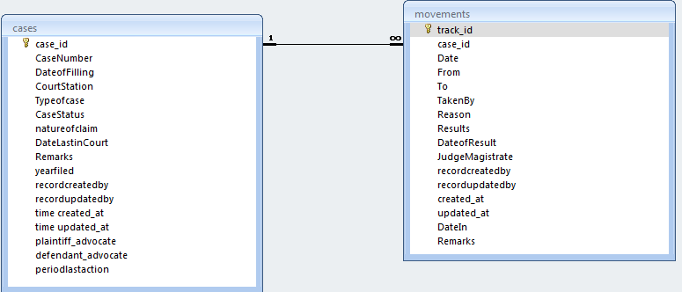

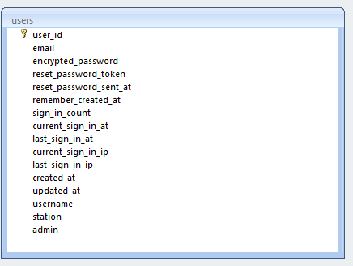

## User Interface

### Forms Design

#### Log in form

Figure 5: Log in form

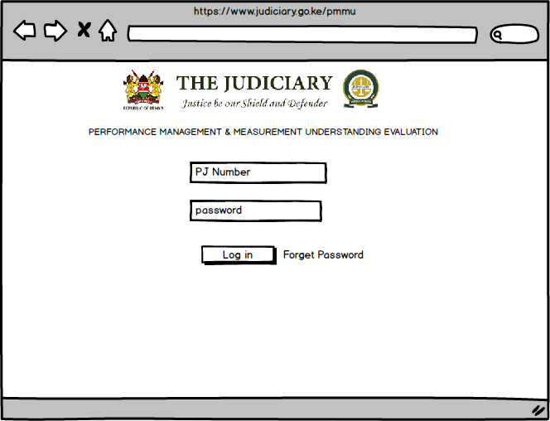

#### Admin Dashboard

Figure 6: Admin Main page

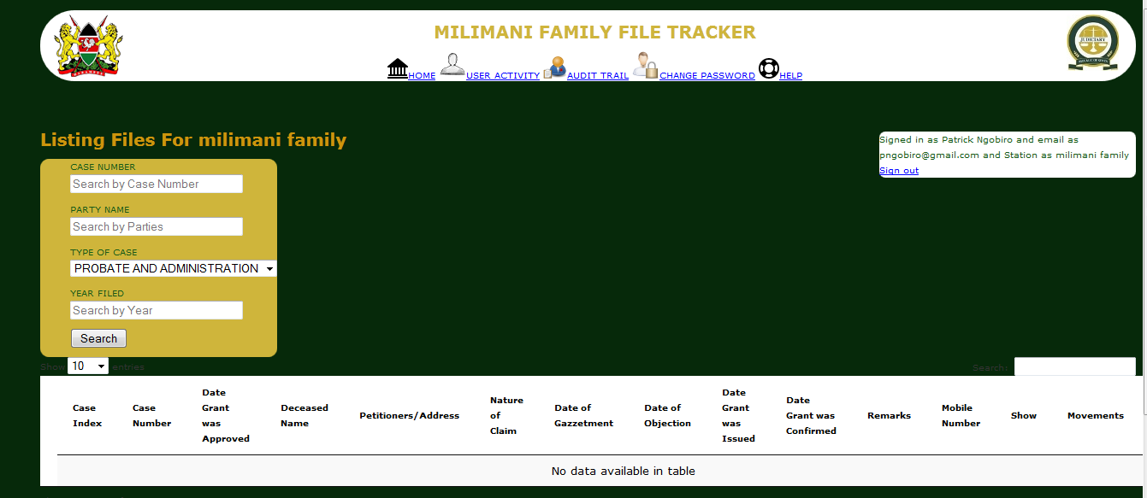

## Reports

All indicators in Excel format (each sheet courts in same rank)

Trends Report

* + OVERALL Score across Financial Year

Missing values Report